##### A Project report on

**Agricultural crop recommendations based on productivity**

**and season**

###### A Dissertation submitted to JNTU Hyderabad in partial fulfillment of the academic requirements for the award of the degree.

**Bachelor of Technology**

**in**

**Computer Science and Engineering**

Submitted by

P.SAI CHARAN

(19H51A05E2)

B. KARTHIK REDDY

(19H51A0505)

B. RAJESH

(18H51A05F6)

Under the esteemed guidance of

Mrs. P. SUMATHI

Asst. prof



**Department of Computer Science and Engineering**

**CMR COLLEGE OF ENGINEERING & TECHNOLOGY**

(An Autonomous Institution under UGC & JNTUH, Approved by AICTE, Permanently Affiliated to JNTUH, Accredited by NBA.)

KANDLAKOYA, MEDCHAL ROAD, HYDERABAD - 501401.

#### 2019- 2023

**CMR COLLEGE OF ENGINEERING & TECHNOLOGY**

KANDLAKOYA, MEDCHAL ROAD, HYDERABAD – 501401

**DEPARTMENT OF COMPUTER SCIENCE AND ENGINEERING**



#### CERTIFICATE

This is to certify that the Major Project Phase-2 report entitled **"AGRICULTURAL CROP RECOMMENDATIONS BASED ON PRODUCTIVITY AND SEASON "** being submitted by P.SAI CHARAN

(19H51A05E2), B.KARTHIKREDDY(19H51A0505), B.RAJESH(18H51A05F6) in partial fulfillment for the award of **Bachelor of Technology in Computer Science and Engineering** is a record of bonafide work carried out his/her under my guidance and supervision.

###### The results embodies in this project report have not been submitted to any other University or Institute for the award of any Degree.

**Mrs.P.Sumathi Dr. Siva Skandha Sanagala**

**Asst.professor Associate Professor and HOD**

**Dept. of CSE Dept. of CSE**

#### ACKNOWLEDGEMENT

With great pleasure we want to take this opportunity to express my heartfelt gratitude to all the people who helped in making this project work a grand success.

We are grateful to **Mrs. P. Sumathi, Asst.professor**, Department of Computer Science and Engineering for her valuable technical suggestions and guidance during the execution of this project work.

We would like to thank **Dr. Siva Skandha Sanagala,** Head of the Department of Computer Science and Engineering, CMR College of Engineering and Technology, who is the major driving forces to complete my project work successfully.

We are very grateful to **Dr. Vijaya Kumar Koppula**, Dean-Academic, CMR College of Engineering and Technology, for his constant support and motivation in carrying out the project work successfully.

We are highly indebted to **Dr. V A Narayana,** Principal, CMR College of Engineering and Technology, for giving permission to carry out this project in a successful and fruitful way.

We would like to thank the Teaching & Non- teaching staff of Department of Computer Science and Engineering for their co-operation

We express our sincere thanks to **Mr. Ch. Gopal Reddy**, Secretary, CMR Group of Institutions, for his continuous care.

Finally, We extend thanks to our parents who stood behind us at different stages of this Project. We sincerely acknowledge and thank all those who gave support directly and indirectly in completion of this project work.

P. SAICHARAN -19H51A05E2

B. KARTHIKREDDY-19H51A0505

B. RAJESH -18H51A05F6

agricultural crop recommendations based on productivity and season

**TABLE OF CONTENTS**

**CHAPTER**

**NO. TITLE PAGE NO.**

ABSTRACT 1

**1** **INTRODUCTION** 2

1.1 Problem Statement 4

**2** **BACKGROUND WORK** 5

2.1. Crop and prediction model by Shreya S. Bhanose 6

2.1.1.Introduction

2.1.2.Merits,Demerits and Challenges

2.1.3.Implementation of Existing Method1

2.2. An analysis of agricultural soils using data mining techniques by Ramesh Babu 9

2.2.1.Introduction

2.2.2.Merits,Doremerits and Challenges

2.2.3.Implementation of Existing Method2

2.3. Web based recommendation system for farmers by

Kiran shinde 11

2.3.1.Introduction

2.3.2.Merits,Demerits and Challenges

2.3.3.Implementation of Existing Method3

**3 RESULTS AND COMPARISON OF EXISTING SYSTEM**

**4 PROPOSED SYSTEM**

3.1. Objective of Proposed Model 17

3.2. Designing 21

3.3. Algorithms Used for Proposed Model 33

3.4. Stepwise Implementation and Code 36

**5 RESULTS AND DISCUSSION** 46

**6** **CONCLUSION**

5.1 Conclusion 52

**7** **REFERENCES** 55

CMRCET B. Tech (CSE) Page no

**CHAPTER**

**ABSTRACT**

agricultural crop recommendations based on productivity and season

# **ABSTRACT**

As a coastal state, Tamil Nadu faces uncertainty in agriculture which decreases its production. With more population and area, more productivity should be achieved but it cannot be reached. Farmers have words-of-mouth in past decades but now it cannot be used due to climatic factors. Agricultural factors and parameters make the data to get insights about the Agri-facts. Growth of IT world drives some highlights in Agriculture Sciences to help farmers with good agricultural information. Intelligence of applying modern technological methods in the field of agriculture is desirable in this current scenario. Machine Learning Techniques develops a well-defined model with the data and helps us to attain predictions. Agricultural issues like crop prediction, rotation, water requirement, fertilizer requirement and protection can be solved. Due to the variable climatic factors of the environment, there is a necessity to have a efficient technique to facilitate the crop cultivation and to lend a hand to the farmers in their production and management. This may help upcoming agriculturalists to have a better agriculture. A system of recommendations can be provided to a farmer to help them in crop cultivation with the help of data mining. To implement such an approach, crops are recommended based on its climatic factors and quantity. Data Analytics paves a way to evolve useful extraction from agricultural database. Crop Dataset has been analyzed and recommendation of crops is done based on productivity and season***.***

CMRCET B. Tech (CSE) Page No 1

agricultural crop recommendations based on productivity and season

# **CHAPTER 1**

**INTRODUCTION**

CMRCET B. Tech (CSE) Page No 2

agricultural crop recommendations based on productivity and season

**CHAPTER 1**

**INTRODUCTION**

**Agriculture**

Tamil Nadu being 7th largest area in India has 6th largest population. It is the leading producer of agriculture products. Agriculture is the main occupation of Tamil Nadu people. Agriculture has a sound tone in this competitive world. Cauvery is the main source of water. Cauvery delta regions are called as rice bowl of Tamil Nadu. Rice is the major crop grown in Tamil Nadu. Other crops like Paddy, Sugarcane, Cotton, Coconut and groundnut are grown. Bio-fertilizers are produced efficiently. Many areas Farming acts as major source of occupation

C

Agriculture makes a dramatic impact in the economy of a country. Due to the change of natural factors, Agriculture farming is degrading now-a days. Agriculture directly depends on the environmental factors such as sunlight, humidity, soil type, rainfall, Maximum and Minimum Temperature, climate, fertilizers, pesticides etc. Knowledge of proper harvesting of crops is in need to bloom in Agriculture. India has seasons of

1. Winter which occurs from December to March

2. Summer season from April to June

3. Monsoon or rainy season lasting from July to September and

4. Post-monsoon or autumn season occurring from October to November.

CMRCET B. Tech (CSE) Page No 3

**PROBLEM STATEMENT**

Agricultural issues like crop prediction, rotation, water requirement, fertilizer requirement and protection have to be solved and due to the variable climatic factors of the environment, there is a necessity to have a efficient technique to facilitate the crop cultivation and to lend a hand to the farmers in their production and management. This may help upcoming agriculturalists to have a better agriculture. A system of recommendations can be provided to a farmer to help them in crop cultivation with the help of data mining.

Agriculture makes a dramatic impact in the economy of a country. Due to the change of natural factors, Agriculture farming is degrading now-a-days. Agriculture directly depends on the environmental factors such as sunlight humidity, soil type, rainfall, Maximum and Minimum Temperature, climate, fertilizers, pesticides etc.

CMRCET B. Tech (CSE) Page No 4

agricultural crop recommendations based on productivity and season

**CHAPTER 2**

**BACKGROUND WORK**

CMRCET B. Tech (CSE) Page No 5

agricultural crop recommendations based on productivity and season

**CHAPTER 2**

**BACKGROUND WORK**

**EXISTING SYSTEM-1**

**Crop and prediction model by Shreya S. Bhanose**

**INTRODUCTION:**

A crop prediction is a huge problem that occurs. A farmer had an attention in understanding how much produce he is going to expect. Traditionally farmers decide this based on permanent experience for specific yield, plants and weather conditions. Character directly thinks about produce prediction rather than concerning on crop prediction.

If the correct crop is expected then yield will be better. Problem of crop and yield prediction using modified k-means clustering algorithm thereby creating better earnings for berry farmers. Clustering is the process of grouping the data into classes or groupings, so that objects within a cluster have high similarity in agreement to each other but are incredibly dissimilar to objects in option clusters.

A bunch of data objects can be treated collectively during the time that you group and so may be looked at as a classic of data compression. Unlike category, clustering is a powerful means for partitioning the collection of data into organizations based on data likeness and then ascribe labeling to the relatively small number of groups. Clustering is an unsupervised learning as it does not rely on predefined classes and class labeled training examples. Because of this, clustering is a form of learning by observation, rather than learning by examples. Because shown in Figure. 1, the three clusters are

Formed containing data factors depending on center position. The cluster center is shown by + signs. The quality of clusters will depend on how dense it is. So, cluster having more number of points is cluster of good quality

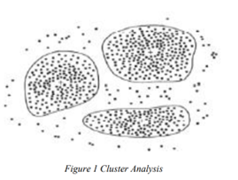

CMRCET B. Tech (CSE) Page No 6

agricultural crop recommendations based on productivity and season

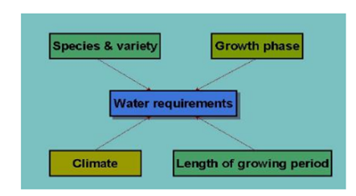**REQUIREMENTS TABLE**

**ARCHITECTURE DESIGN**

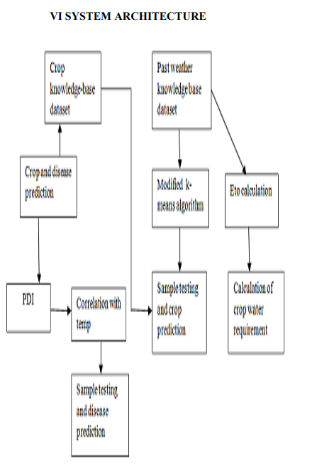

**DIS-ADVANTAGES**

* This system is used for only few crops.
* It is only based on water requirements .
* It is accurate up to 60% only .
* Its only suggest how the crop grows and yields using water.
* It doesnot accurately defines the crop prediction**.**

CMRCET B. Tech (CSE) Page No 7

agricultural crop recommendations based on productivity and season

**IMPLEMENTATION REPORT**

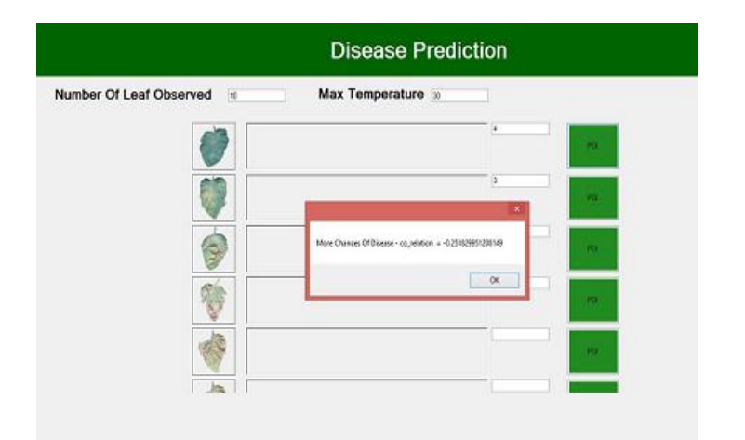

Performance Metrics

|  |  |
| --- | --- |
| **Parameter** | **Performance Metrics** |
| **Accuracy** | 60% |
| **Precision** | 70 |
| **Recall** | 25 |
| **F-measure** | 30.45 |
| Specificity | 20 |

CMRCET B. Tech (CSE) Page No 8

agricultural crop recommendations based on productivity and season

**EXISTING SYSTEM-2**

**An Analysis of Agricultural Soils by using Data Mining Techniques by Ramesh Babu**

**INTRODUCTION**

Agriculture is the most basic function to accomplish food demand all over the globe it is a backbone particularly in the developing countries like India. The application of Data mining techniques in agriculture especially on soils can revise the situation of pledge making and improve cultivation yields in a better way. The analysis of soils plays an indispensable role for resolution making on several issues related to agriculture field. This paper presents about the role of data mining in perspective of soil analysis in the field of agriculture and also confers about several data mining techniques and their related work by several authors in context to soil analysis domain. The data mining techniques are of very up-to-the-minute in the area of soil analysis.

**FLOW CHART**

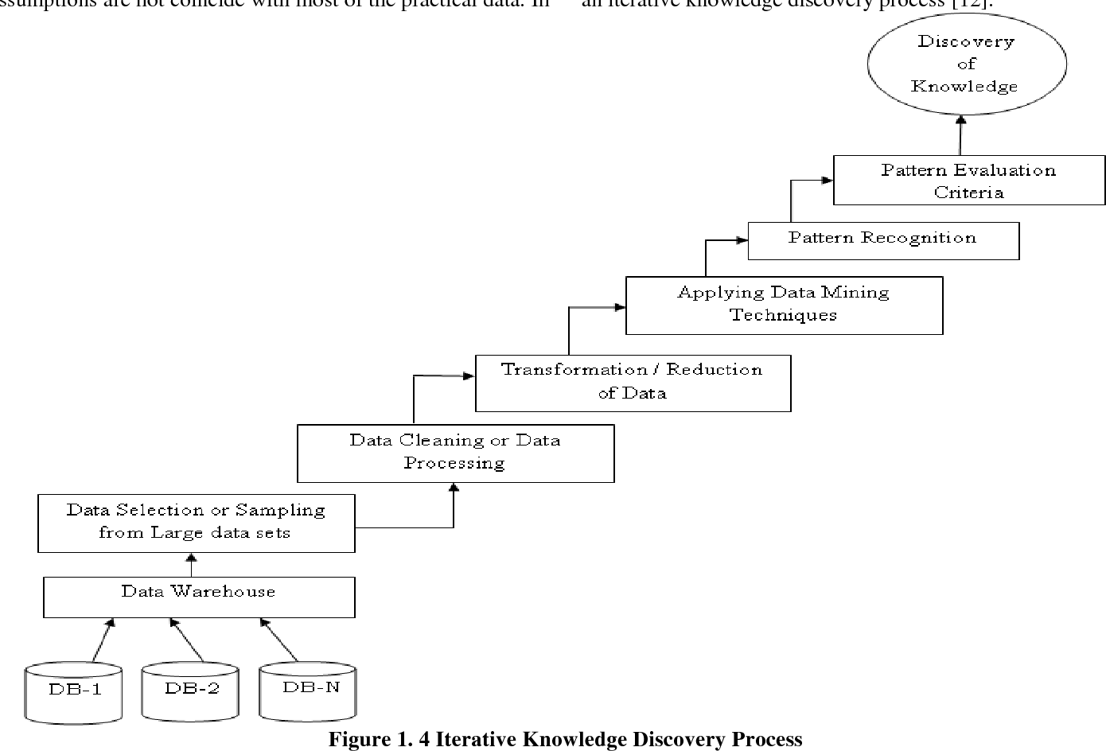

CMRCET B. Tech (CSE) Page No 9

agricultural crop recommendations based on productivity and season

**DIS-ADVANTAGES:**

* It is only based on soil fertility, but not considering other factors.
* Its not highly accurate to recommend the crop.
* Not only soil is enough to recommend a crop. There are many other factors which influence in crop growing.

**DATA MINING PROCESS:**

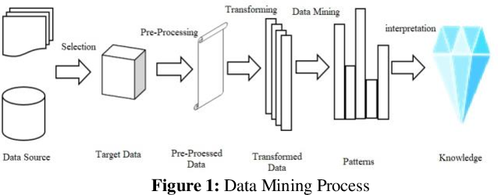

**PERFORMANCE METRICES**

|  |  |
| --- | --- |
| **Parameter** | **Performance Metrics** |
| **Accuracy** | 70% |
| **Precision** | 80 |
| **Recall** | 40 |
| **F-measure** | 45 |
| Specificity | 50 |

CMRCET B. Tech (CSE) Page No 10

agricultural crop recommendations based on productivity and season

**EXISTING SYSTEM-3**

**Web Based Recommendation System for Farmers by kiran shinde**

**INTRODUCTION**

Agriculture is a prime occupation in India from age sand thus plays a vital role in an Indian economy. India is an agricultural country with second highest land area of more than1.4 million square-kilometres under cultivation. India possesses a tremendous potential to be a superpower in the field of agriculture. Agriculture promotes poverty upliftment and rural development.

  Agriculture is India's biggest economic sector and employed 52.1% of total work force in 2009-10. Number of farmers in India is 23.4 crores in 2001. As of 2011, India had a large and diverse agricultural sector, accounting, on average, for about 16% of GDP and 10% of export earnings. Today in India agriculture is being neglected which has led to losing hope of farmers in agriculture which has led to rise in the number of farmer suicides. There is no such universal system to assist farmers in agriculture. India’s population has been

rising at 1.6% per annum, which means that the growth in agricultural production must also increase at this minimum rate to ensure that there are no supply bottle necks. Solutions are obvious India must invest in the agriculture sector, in R&D, in irrigation, intermediary-less sales of produce and effective information centres to provide answers to farmers’ queries.

 In India agricultural is carried out from ages and thus we have a rich collection of agricultural past data which can used for recommendation. Data mining techniques and algorithms can be used for recommending single crop and pattern of crops for crop-rotation. How-ever to obtain optimized and valid results system needs to be in continuous learning which can be done by including latest datasets in the system

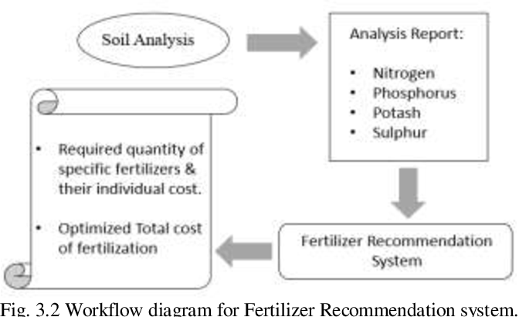**WORK FLOW DIAGRAM:**

CMRCET B. Tech (CSE) Page No 11

agricultural crop recommendations based on productivity and season

**CROP REQUIREMENTS**

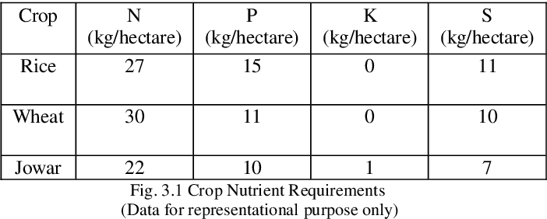

**IMPLEMENTATION PROCESS**

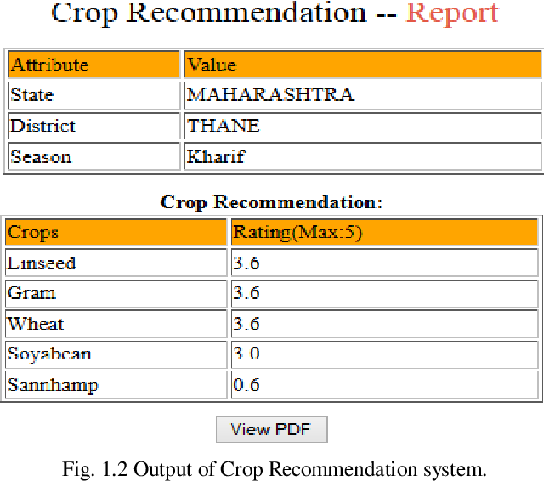

CMRCET B. Tech (CSE) Page No 12

agricultural crop recommendations based on productivity and season

**CHAPTER 3**

**RESULTS OF EXISTING SYSYTEM**

CMRCET B. Tech (CSE) Page No 13

agricultural crop recommendations based on productivity and season

**CHAPTER 3**

**COMPARISON OF EXISTING SOLUTIONS**

Performance metrices

|  |  |  |  |
| --- | --- | --- | --- |
| Parameter | Ex-1 | Ex-2 | Ex-3 |
| Accuracy | 60% | 70% | 75% |
| Precision | 70 | 80 | 72 |
| Recall | 75 | 40 | 40 |
| F-measure | 30.45 | 45 | 60 |
| Specifity | 20 | 50 | 60 |

CMRCET B. Tech (CSE) Page No 14

agricultural crop recommendations based on productivity and season

**DIS-ADVANTAGES OF EXISTING SYSTEM**

1. An existing system’s recommendation is based on soil and not based on Crop Recommendation Based on Production.
2. Farmers will be given recommendation by considering not the season of crop production.

CMRCET B. Tech (CSE) Page No 15

agricultural crop recommendations based on productivity and season

**CHAPTER-4**

**PROPOSED SYSTEM**

CMRCET B. Tech (CSE) Page No 16

agricultural crop recommendations based on productivity and season

**OBJECTIVE**

Tamil Nadu being 7th largest area in India has 6th largest population. It is the leading producer of agriculture products. Agriculture is the main occupation of Tamil Nadu people. Agriculture has a sound tone in this competitive world. Cauvery is the main source of water. Cauvery delta regions are called as rice bowl of Tamil Nadu. Rice is the major crop grown in Tamil Nadu. Other crops like Paddy, Sugarcane, Cotton, Coconut and groundnut are grown. Bio-fertilizers are produced efficiently. Many areas Farming acts as major source of occupation

Agriculture makes a dramatic impact in the economy of a country. Due to the change of natural factors, Agriculture farming is degrading now-a days. Agriculture directly depends on the environmental factors such as sunlight, humidity, soil type, rainfall, Maximum and Minimum Temperature, climate, fertilizers, pesticides etc. Knowledge of proper harvesting of crops is in need to bloom in Agriculture. India has seasons of

1. Winter which occurs from December to March

2. Summer season from April to June

3. Monsoon or rainy season lasting from July to September and

4. Post-monsoon or autumn season occurring from October to November.

CMRCET B. Tech (CSE) Page No 17

agricultural crop recommendations based on productivity and season

Due to the diversity of season and rainfall, assessment of suitable crops to cultivate is necessary. Farmers face major problems such as crop management, expected crop yield an productive yield from the crops. Farmers or cultivators need proper assistant regarding crop cultivation as now-a-days many fresh youngsters are interested in agriculture.

Impact of IT sector in assessing real world problem is moving at a faster rate. Data is increasing day by day in field of agriculture. With the advancement in Internet of Things, there are ways to grasp huge data in field of Agriculture. There is a need of a system to have obvious analyzes of data of agriculture and extract or use useful information from the spreading data. To get insights from data, it has to be learnt.

**Knowledge discovery in databases**:

Extracting knowledge from the data set is the process of mining. It aims to give accurate results to farmers. It finds hidden patterns. It discovers useful knowledge from the tremendous data set. It is one of the processes in Knowledge Discovery in Databases (KDD). Apart from the KDD process, in recent days with the development in IT world, Machine Learning has emerged to handle big volume of data and involves high performance computing too. Application of Machine Learning in Agriculture peaks up day by day. Machine Learning techniques are used in crop management, livestock management, water management and soil management recommendation algorithm. They provide personalized products in E-Commerce. These recommendation concepts are used in agriculture in this paper to provide crops to sow. Simple Data Analytics is used on crop dataset and personalization of agricultural crops are suggested to famers.

CMRCET B. Tech (CSE) Page No 18

agricultural crop recommendations based on productivity and season

Prediction of crops was done according to farmer’s experience in the past years. Although farmer’s knowledge sustains, agricultural factors has been changed to astonishing level. There comes a need to indulge engineering effect in crop prediction. Data mining plays a novel role in agriculture research. This field uses historical data to predict; such techniques are neural networks, K-nearest Neighbor. K-means algorithm does not use historical data but predicts based on-computing centers of the samples and forming clusters. Computational cost of algorithm acts as a major issue. Use of Artificial Neural Network is a boon to agriculture field which computes accurately even with more input. An architecture developed in uses input; selects needed features; classification and association rule mining is applied and visualized.

Bangladesh has its high production as rice. Statistical Methodologies has been used to predict its crop production. Shakil Ahamed applied clustering and classification techniques on 15 districts of Bangladesh to recommend for yield and planting of crops. Factors implementing crop yield were considered. They are

a. Environmental factors-rainfall, humidity, Minimum and maximum temperature

b. Biotic factors-soil pH and salinity

c. Area factors-irrigated or cultivated

.

CMRCET B. Tech (CSE) Page No 19

agricultural crop recommendations based on productivity and season

Based upon the factors of agriculture, farmers are given with ideas for their cultivation process. New techniques to increase crop cultivation can also be recommended. Pesticides, fertilizers can also be recommended. Hybrid Recommender system built to recommend agricultural products solves issues like serendipity, ratio diffusion and ramp-up.

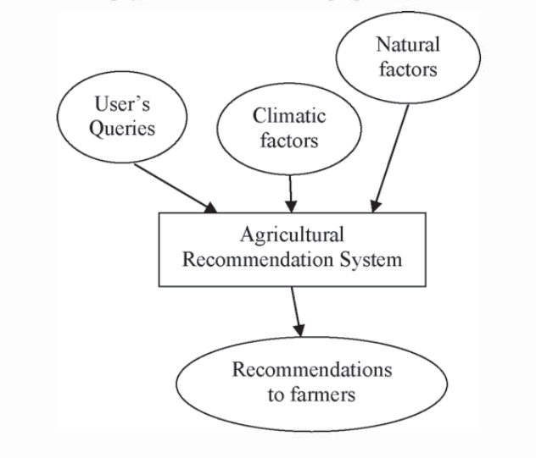

CMRCET B. Tech (CSE) Page No 20

agricultural crop recommendations based on productivity and season

**DESIGNING**

**MODULES OF THE SYSTEM**

**Service Provider**

In this module, the Service Provider has to login by using valid user name and password. After login successful he can do some operations such as View Crop Data Sets, Browse Agriculture Data Sets and Train & Test, View Trained and Tested Accuracy in Bar Chart, View Trained and Tested Accuracy Results, View All Crop Yield and Production Prediction, Download Predicted Data Sets, View All Remote Users, View Crop Yield Prediction Per Acre Results..

**View and Authorize Users**

In this module, the admin can view the list of users who all registered. In this, the admin can view the user’s details such as, user name, email, address and admin authorizes the users.

**Remote User**

In this module, there are n numbers of users are present. User should register before doing any operations. Once user registers, their details will be stored to the database. After registration successful, he has to login by using authorized user name and password. Once Login is successful user will do some operations like POST CROPS DATA SETS, PREDICT CROP YIELD AND PRODUCTION, VIEW YOUR PROFILE.

CMRCET B. Tech (CSE) Page No 21

agricultural crop recommendations based on productivity and season

**SYSTEM STUDY**

**1. FEASIBILITY STUDY**

The feasibility of the project is analyzed in this phase and business proposal is put forth with a very general plan for the project and some cost estimates. During system analysis the feasibility study of the proposed system is to be carried out. This is to ensure that the proposed system is not a burden to the company. For feasibility analysis, some understanding of the major requirements for the system is essential.

Three key considerations involved in the feasibility analysis are

* ECONOMICAL FEASIBILITY
* TECHNICAL FEASIBILITY
* SOCIAL FEASIBILITY

CMRCET B. Tech (CSE) Page No 22

agricultural crop recommendations based on productivity and season

**ECONOMICAL FEASIBILITY**

This study is carried out to check the economic impact that the system will have on the organization. The amount of fund that the company can pour into the research and development of the system is limited. The expenditures must be justified. Thus the developed system as well within the budget and this was achieved because most of the technologies used are freely available. Only the customized products had to be purchased.

### TECHNICAL FEASIBILITY

This study is carried out to check the technical feasibility, that is, the technical requirements of the system. Any system developed must not have a high demand on the available technical resources. This will lead to high demands on the available technical resources. This will lead to high demands being placed on the client. The developed system must have a modest requirement, as only minimal or null changes are required for implementing this system.

CMRCET B. Tech (CSE) Page No 23

agricultural crop recommendations based on productivity and season

**SOCIAL FEASIBILITY**

The aspect of study is to check the level of acceptance of the system by the user. This includes the process of training the user to use the system efficiently. The user must not feel threatened by the system, instead must accept it as a necessity. The level of acceptance by the users solely depends on the methods that are employed to educate the user about the system and to make him familiar with it. His level of confidence must be raised so that he is also able to make some constructive criticism, which is welcomed, as he is the final user of the system.

CMRCET B. Tech (CSE) Page No 24

agricultural crop recommendations based on productivity and season

**SOFTWARE REQUIREMENTS:**

* **Operating system :** Windows 7 Ultimate.
* **Coding Language :** Python.
* **Front-End :** Python.
* **Back-End :** Django-ORM
* **Designing :** Html, css, javascript.
* **Data Base :** MySQL (WAMP Server).

CMRCET B. Tech (CSE) Page No 25

agricultural crop recommendations based on productivity and season

**SYSTEM REQUIREMENTS**

➢ **H/W System Configuration:-**

➢ Processor - Pentium –IV

➢ RAM - 4 GB (min)

➢ Hard Disk - 20 GB

➢ Key Board - Standard Windows Keyboard

➢ Mouse - Two or Three Button Mouse

➢ Monitor - SVGA

CMRCET B. Tech (CSE) Page No 26

agricultural crop recommendations based on productivity and season

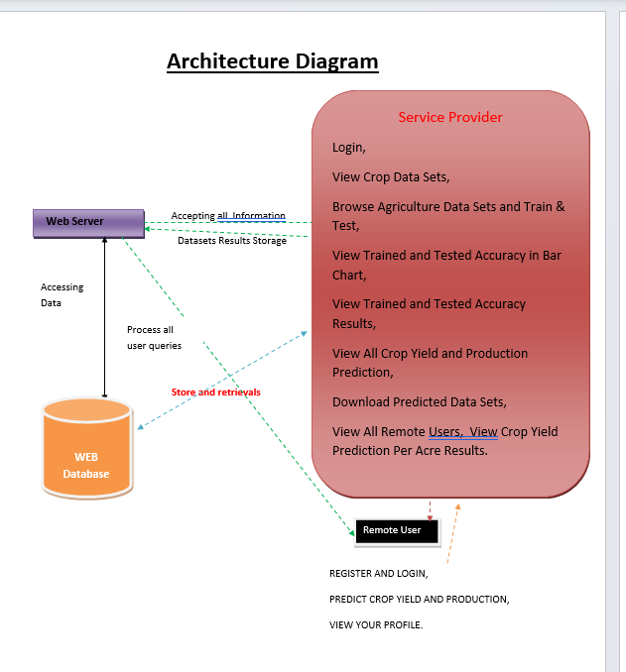 **ARCHITECTURE**



CMRCET B. Tech (CSE) Page No 27



agricultural crop recommendations based on productivity and season

**SEQUENCE DIAGRAM**

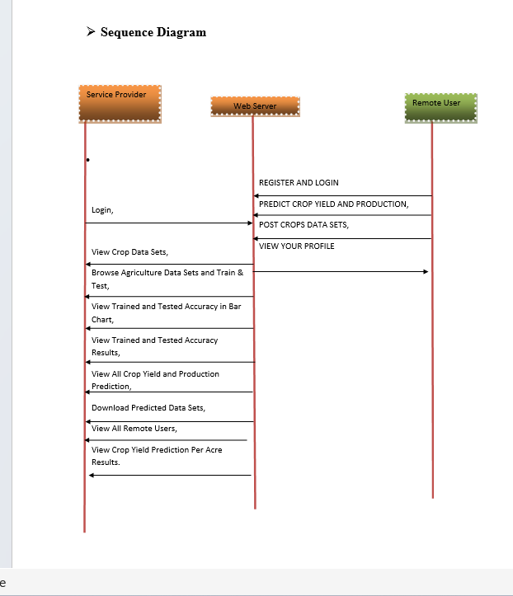



CMRCET B. Tech (CSE) Page No 28

agricultural crop recommendations based on productivity and season

**CLASS DIADRAM**

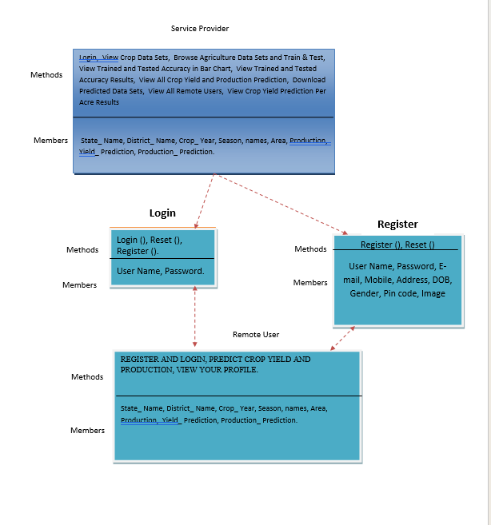

CMRCET B. Tech (CSE) Page No 29

agricultural crop recommendations based on productivity and season

**DATA FLOW DIAGRAM**

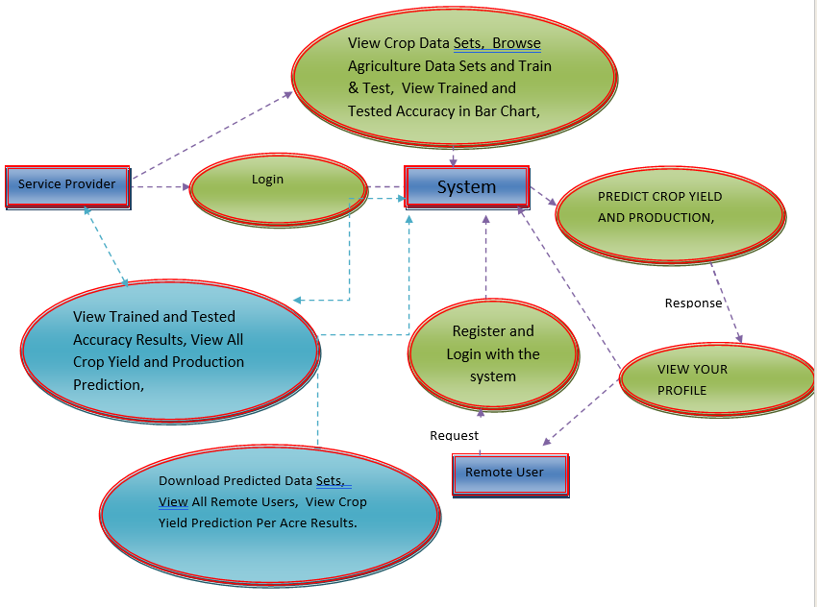

CMRCET B. Tech (CSE) Page No 30

agricultural crop recommendations based on productivity and season

**FLOW CHART: REMOTE USER**

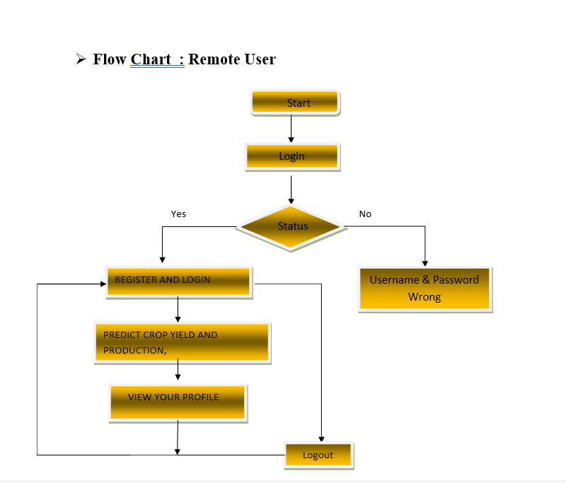



CMRCET B. Tech (CSE) Page No 31

agricultural crop recommendations based on productivity and season

**FLOW CHART: SERVICE PROVIDER**

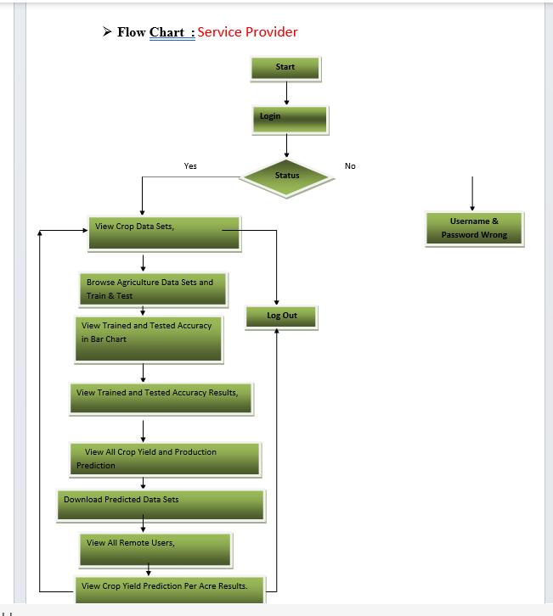



CMRCET B. Tech (CSE) Page No 32

agricultural crop recommendations based on productivity and season

**ALGORITHMS USED**

**DECISION TREE ALGORITHM**

Decision Tree is a Supervised learning technique that can be used for both classification and Regression problems, but mostly it is preferred for solving Classification problems. It is a tree-structured classifier, where internal nodes represent the features of a dataset, branches represent the decision rules and each leaf node represents the outcome.

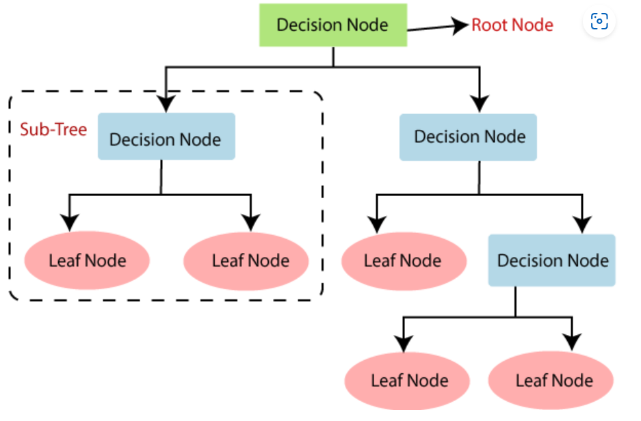

CMRCET B. Tech (CSE) Page No 33

agricultural crop recommendations based on productivity and season

**RANDOM FOREST ALGORITHM**

* Random Forest is a classifier that contains a number of decision trees on various subsets of the given dataset and takes the average to improve the predictive accuracy of that dataset.

Below are some points that explain why we should use the Random Forest algorithm:

* It takes less training time as compared to other algorithms.
* It predicts output with high accuracy, even for the large dataset it runs efficiently.
* It can also maintain accuracy when a large proportion of data is missing

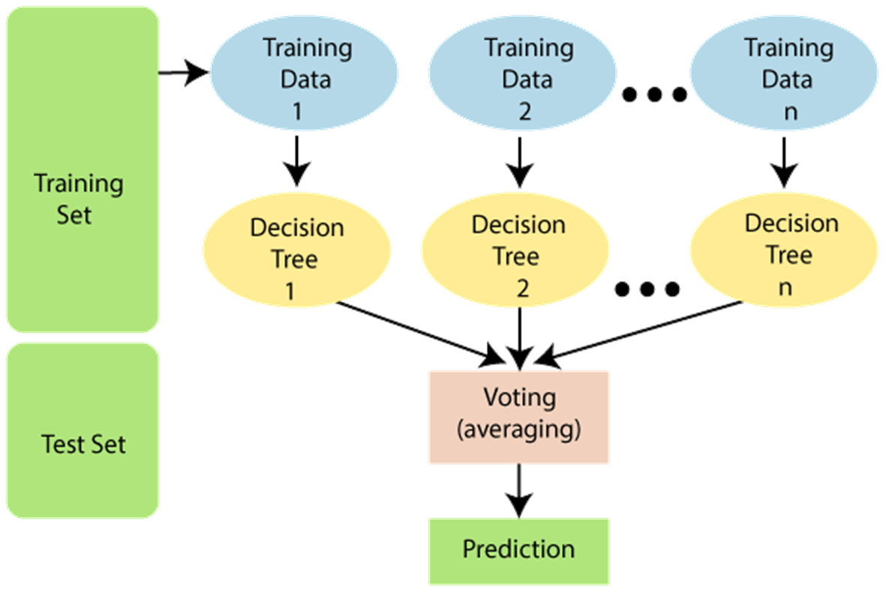

CMRCET B. Tech (CSE) Page No 34

agricultural crop recommendations based on productivity and season

**PASSIVE AGGRESSIVE ALGORITHM**

Passive-Aggressive algorithms are generally used for large-scale learning. It is one of the **online-learning algorithms**. In online machine learning algorithms, the input data comes in sequential order and the machine learning model is updated sequentially, as opposed to conventional batch learning, where the entire training dataset is used at once.

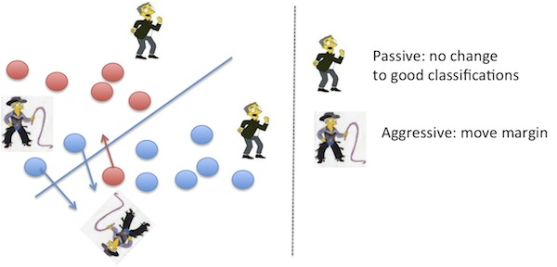

CMRCET B. Tech (CSE) Page No 35

agricultural crop recommendations based on productivity and season

**IMPLEMENTATION CODE**

from tkinter import *

import tkinter

from tkinter import filedialog

import numpy as np

from tkinter.filedialog import askopenfilename

import pandas as pd

from tkinter import simpledialog

import matplotlib.pyplot as plt

import os

import pandas as pd

import numpy as np

from keras.models import Sequential

from keras.layers.core import Dense,Activation,Dropout, Flatten

from keras.utils.np_utils import to_categorical

from sklearn.model_selection import train_test_split

from sklearn.preprocessing import LabelEncoder

import keras.layers

from keras.models import model_from_json

import pickle

from sklearn.preprocessing import StandardScaler

from sklearn.metrics import accuracy_score

from sklearn.ensemble import RandomForestClassifier

from sklearn.linear_model import PassiveAggressiveClassifier

main = tkinter.Tk()

CMRCET B. Tech (CSE) Page No 36

agricultural crop recommendations based on productivity and season

main.title("Agricultural Crop Recommendation Based on productivity and season")

main.geometry("1000x650")

global train, test, X_train, X_test, y_train, y_test

global filename

global cls

def upload():

global filename

filename = filedialog.askopenfilename(initialdir="dataset")

text.delete('1.0', END)

text.insert(END,filename+" loaded\n");

def traintest(data): #method to generate test and train data from dataset

train=data.iloc[:, 0:7].values

test=data.iloc[: ,8].values

print(train)

print(test)

X_train, X_test, y_train, y_test = train_test_split(

train, test, test_size = 0.3, random_state = 0)

return train, test, X_train, X_test, y_train, y_test

CMRCET B. Tech (CSE) Page No 37

agricultural crop recommendations based on productivity and season

def generateModel(): #method to read dataset values which contains all features data

global train, test, X_train, X_test, y_train, y_test

train1 = pd.read_csv(filename)

train, test, X_train, X_test, y_train, y_test = traintest(train1)

text.insert(END,"Train & Test Model Generated\n\n")

text.insert(END,"Total Dataset Size : "+str(len(train1))+"\n")

text.insert(END,"Split Training Size : "+str(len(X_train))+"\n")

text.insert(END,"Split Test Size : "+str(len(X_test))+"\n")

def prediction(X_test, cls): #prediction done here

y_pred = cls.predict(X_test)

for i in range(50):

print("X=%s, Predicted=%s" % (X_test[i], y_pred[i]))

return y_pred

# Function to calculate accuracy

def cal_accuracy(y_test, y_pred, details):

accuracy = accuracy_score(y_test,y_pred)*100

text.insert(END,details+"\n\n")

text.insert(END,"Accuracy : "+str(accuracy)+"\n\n")

return accuracy

def runDCT():

global dct_acc

CMRCET B. Tech (CSE) Page No 38

agricultural crop recommendations based on productivity and season

global cls

global train, test, X_train, X_test, y_train, y_test

#Importing Decision Tree classifier

from sklearn.tree import DecisionTreeRegressor

cls=DecisionTreeRegressor()

#Fitting the classifier into training set

cls.fit(X_train,y_train)

text.insert(END,"Prediction Results\n\n")

prediction_data = prediction(X_test, cls)

dct_acc = cal_accuracy(y_test, prediction_data,'Decision Tree Accuracy')

def runRF():

global random_acc

global cls

global train, test, X_train, X_test, y_train, y_test

#Importing Decision Tree classifier

rf=RandomForestClassifier(n_estimators=50,max_depth=2,random_state=0,class_weight='balanced')

#Fitting the classifier into training set

rf.fit(X_train,y_train)

text.insert(END,"Prediction Results\n\n")

CMRCET B. Tech (CSE) Page No 39

agricultural crop recommendations based on productivity and season

prediction_data = prediction(X_test, rf)

random_acc = cal_accuracy(y_test, prediction_data,'Random Forest Accuracy')

def runPAC():

global pac_acc

global cls

global train, test, X_train, X_test, y_train, y_test

linear_clf = PassiveAggressiveClassifier()

linear_clf.fit(X_train,y_train)

text.insert(END,"Prediction Results\n\n")

prediction_data = prediction(X_test, linear_clf)

pac_acc = cal_accuracy(y_test, prediction_data,'Random Forest Accuracy')

def predicts():

global clean

global attack

global total

clean = 0;

attack = 0;

text.delete('1.0', END)

filename = filedialog.askopenfilename(initialdir="dataset")

test = pd.read_csv(filename)

test = test.values[:, 0:7]

CMRCET B. Tech (CSE) Page No 40

agricultural crop recommendations based on productivity and season

total = len(test)

text.insert(END,filename+" test file loaded\n");

y_pred = cls.predict(test)

#text.insert(END,y_pred+" \n");

print(y_pred)

'''for i in range(len(y_pred)):

text.insert(END,i," \n");'''

for i in range(len(test)):

if str(y_pred[i]) == '1.0':

attack = attack + 1

text.insert(END,"X=%s, Predicted = %s" % (test[i], 'Crop name is rice')+"\n\n")

elif str(y_pred[i]) == '2.0':

clean = clean + 1

text.insert(END,"X=%s, Predicted = %s" % (test[i], 'crop name is wheat')+"\n\n")

elif str(y_pred[i]) == '3.0':

clean = clean + 1

text.insert(END,"X=%s, Predicted = %s" % (test[i], 'crop name is Mung Bean')+"\n\n")

elif str(y_pred[i]) == '4.0':

clean = clean + 1

text.insert(END,"X=%s, Predicted = %s" % (test[i], 'crop name is Tea')+"\n\n")

elif str(y_pred[i]) == '5.0':

CMRCET B. Tech (CSE) Page No 41

agricultural crop recommendations based on productivity and season

clean = clean + 1

text.insert(END,"X=%s, Predicted = %s" % (test[i], 'crop name is millet')+"\n\n")

elif str(y_pred[i]) == '6.0':

clean = clean + 1

text.insert(END,"X=%s, Predicted = %s" % (test[i], 'crop name is maize')+"\n\n")

elif str(y_pred[i]) == '7.0':

clean = clean + 1

text.insert(END,"X=%s, Predicted = %s" % (test[i], 'crop name is Lentil')+"\n\n")

def graph():

height = [dct_acc,random_acc,pac_acc]

bars = ('Decission tree','Random forest','PassiveAggressiveClassifier')

y_pos = np.arange(len(bars))

plt.bar(y_pos, height)

plt.xticks(y_pos, bars)

plt.show()

font = ('times', 15, 'bold')

title = Label(main, text='Agricultural Crop Recommendation Based on Productivity and Season', justify=LEFT)

title.config(bg='lavender blush', fg='DarkOrchid1')

CMRCET B. Tech (CSE) Page No 42

agricultural crop recommendations based on productivity and season

title.config(font=font)

title.config(height=3, width=120)

title.place(x=100,y=5)

title.pack()

font1 = ('times', 12, 'bold')

uploadButton = Button(main, text="Upload Agriculture Dataset", command=upload)

uploadButton.place(x=10,y=100)

uploadButton.config(font=font1)

preprocessButton = Button(main, text="Preprocess Dataset", command=generateModel)

preprocessButton.place(x=300,y=100)

preprocessButton.config(font=font1)

rnnButton = Button(main, text="Run Decisiontree Algorithm", command=runDCT)

rnnButton.place(x=480,y=100)

rnnButton.config(font=font1)

lstmButton = Button(main, text="Run Randomforest Algorithm", command=runRF)

lstmButton.place(x=700,y=100)

lstmButton.config(font=font1)

CMRCET B. Tech (CSE) Page No 43

agricultural crop recommendations based on productivity and season

ffButton = Button(main, text="Run Passive Aggressive Algorithm", command=runPAC)

ffButton.place(x=10,y=150)

ffButton.config(font=font1)

graphButton = Button(main, text="Run Accuracy Comparison Graph", command=graph)

graphButton.place(x=300,y=150)

graphButton.config(font=font1)

predictButton = Button(main, text="Detect Crop", command=predicts)

predictButton.place(x=550,y=150)

predictButton.config(font=font1)

'''

predictButton = Button(main, text="Predict Disease using Test Data", command=predict)

predictButton.place(x=10,y=200)

predictButton.config(font=font1)

topButton = Button(main, text="Top 6 Crop Yield Graph", command=topGraph)

topButton.place(x=300,y=200)

topButton.config(font=font1)'''

font1 = ('times', 12, 'bold')

text=Text(main,height=20,width=160)

CMRCET B. Tech (CSE) Page No 44

agricultural crop recommendations based on productivity and season

scroll=Scrollbar(text)

text.configure(yscrollcommand=scroll.set)

text.place(x=10,y=250)

text.config(font=font1)

main.config(bg='light coral')

main.mainloop()

CMRCET B. Tech (CSE) Page No 45

**Chapter-5 RESULTS AND SCUSSION**

agricultural crop recommendations based on productivity and season

**IMAGES OF OUTPUT**

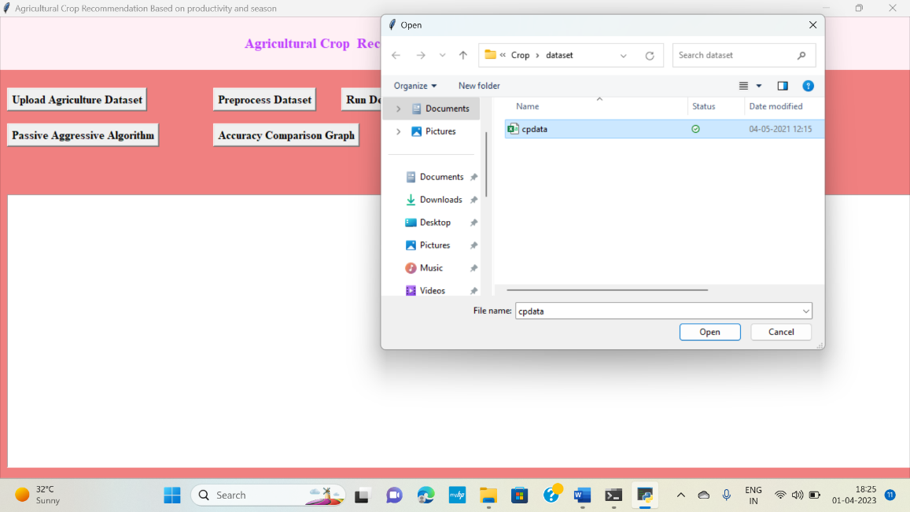**UPLOADING THE DATA SET**

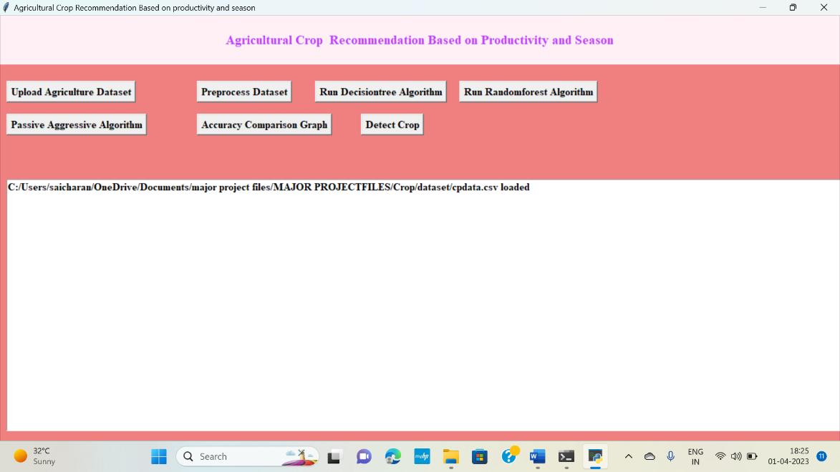

CMRCET B. Tech (CSE) Page No 46

agricultural crop recommendations based on productivity and season

**PREPROCESSING THE DATA SET**

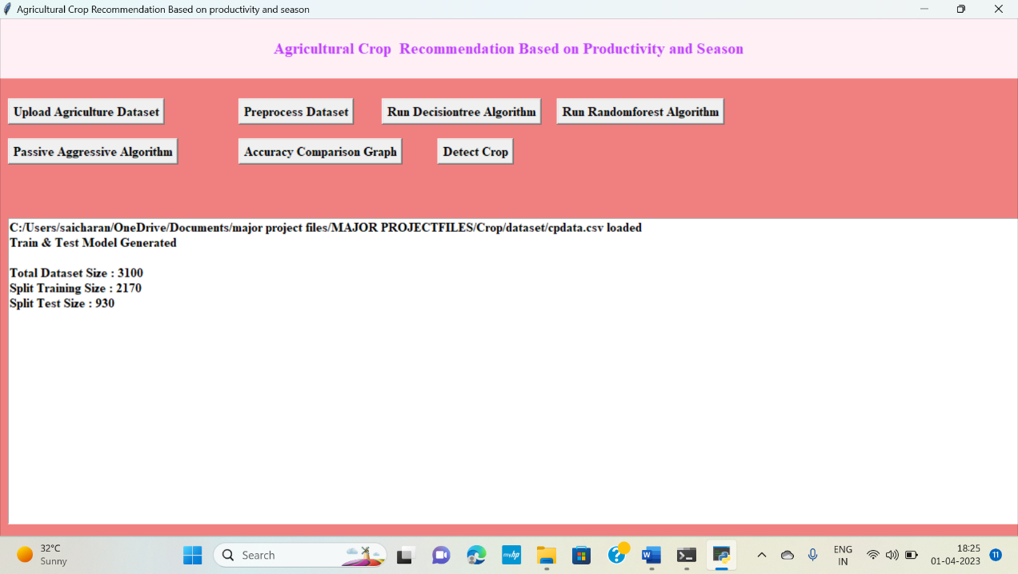

**RUNNING THE DECISION TREE ALGORITHM**

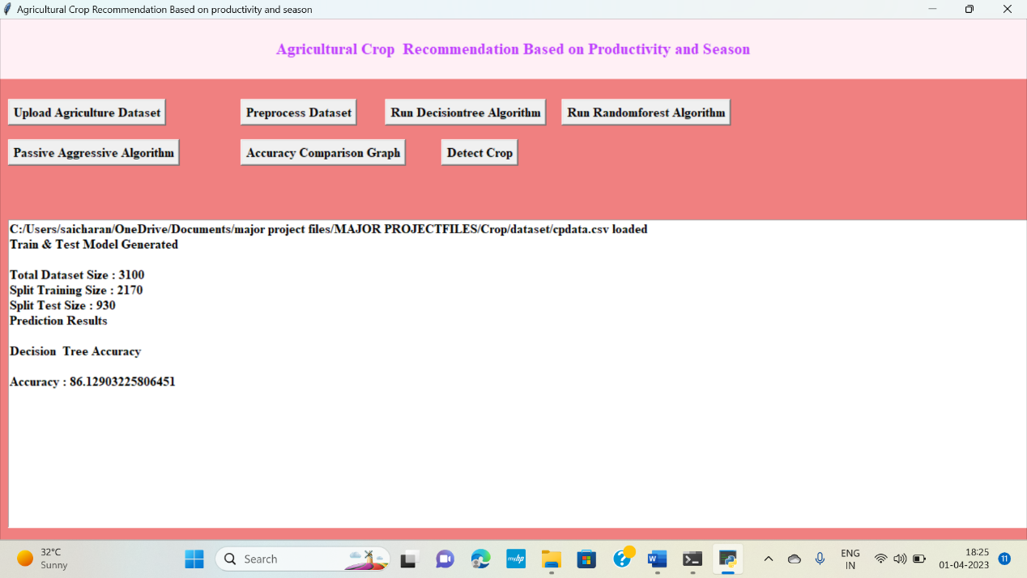

CMRCET B. Tech (CSE) Page No 47

agricultural crop recommendations based on productivity and season

**RUNNING RANDOM FOREST ALGORITHM**

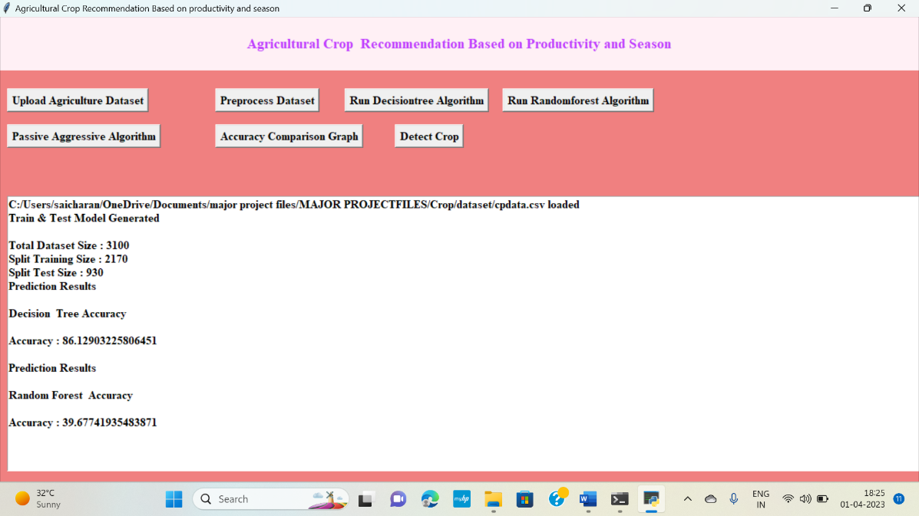

**RUNNING PASSIVE AGGRESSIVE ALGORITHM**

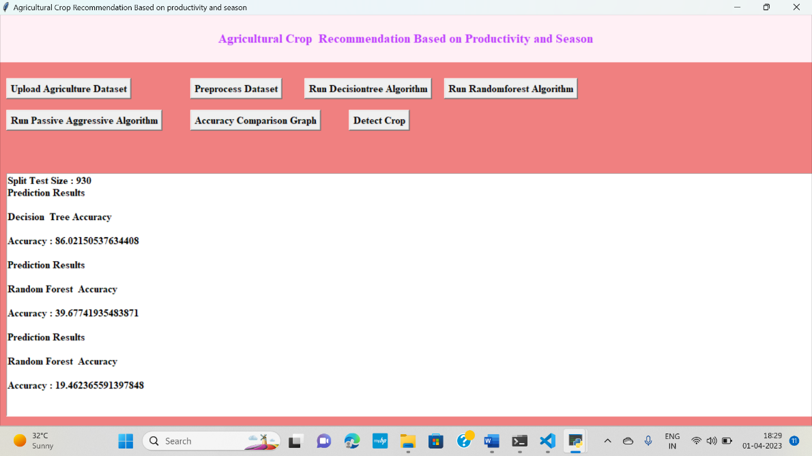

CMRCET B. Tech (CSE) Page No 48

agricultural crop recommendations based on productivity and season

**ACCURACY COMPARISON GRAPH**

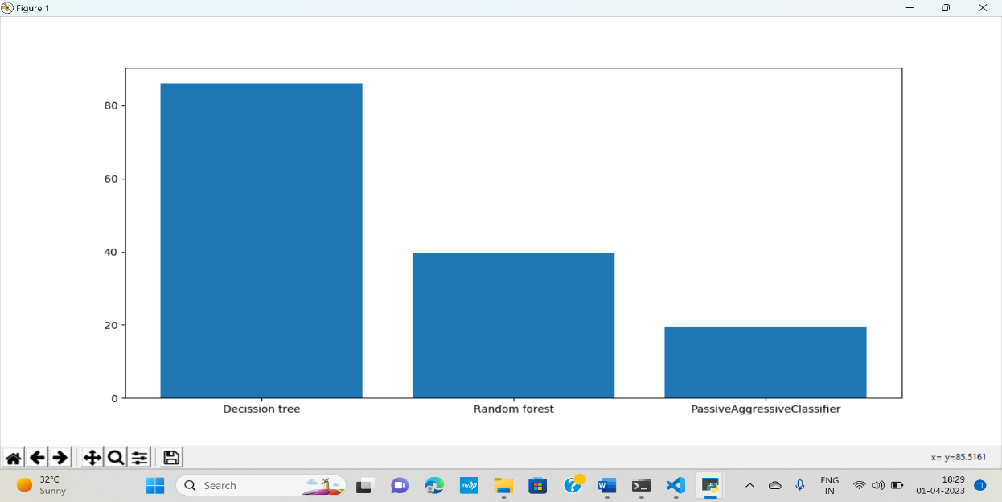

**FINAL OUTPUT USING DATASET**

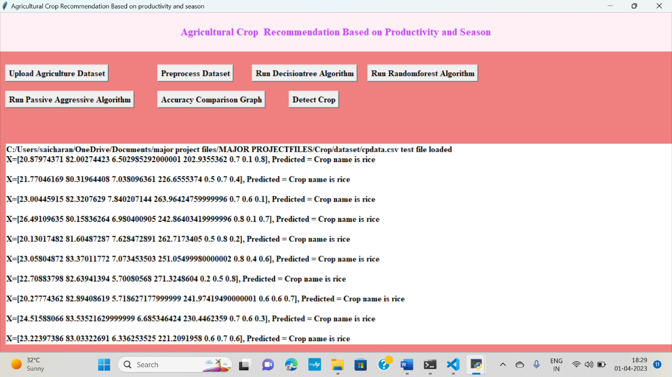

CMRCET B. Tech (CSE) Page No 49

agricultural crop recommendations based on productivity and season

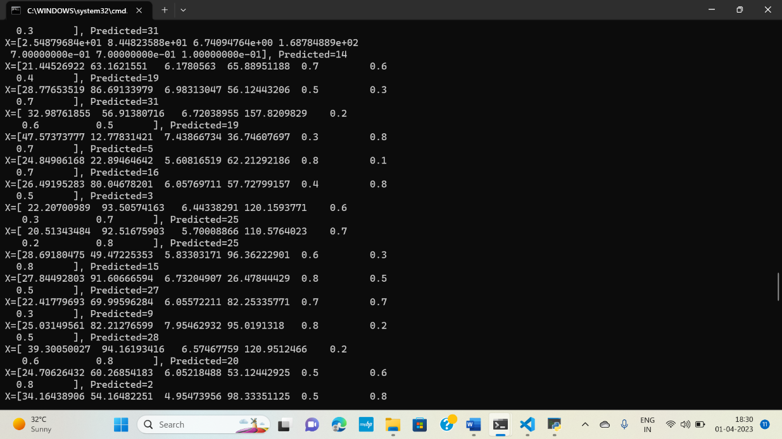

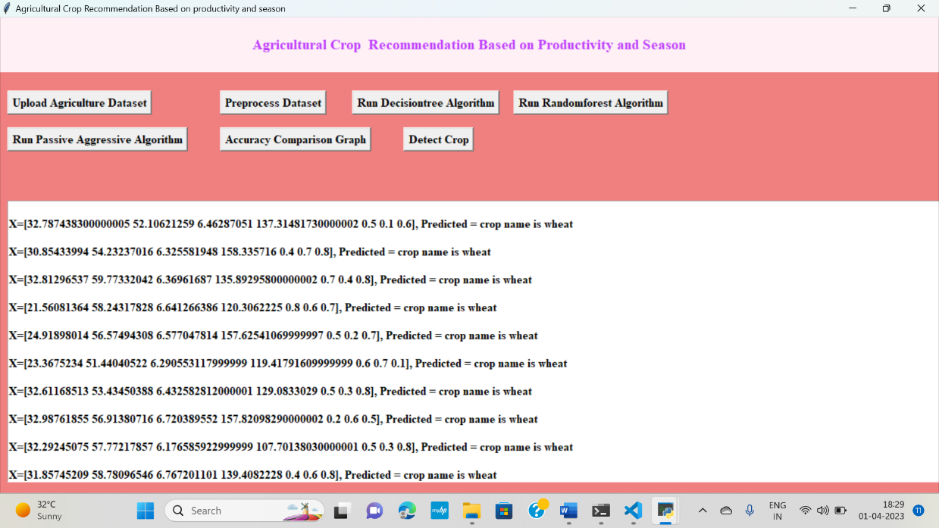

CMRCET B. Tech (CSE) Page No 50

agricultural crop recommendations based on productivity and season

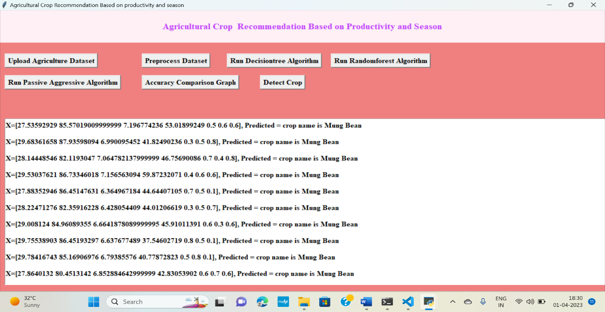

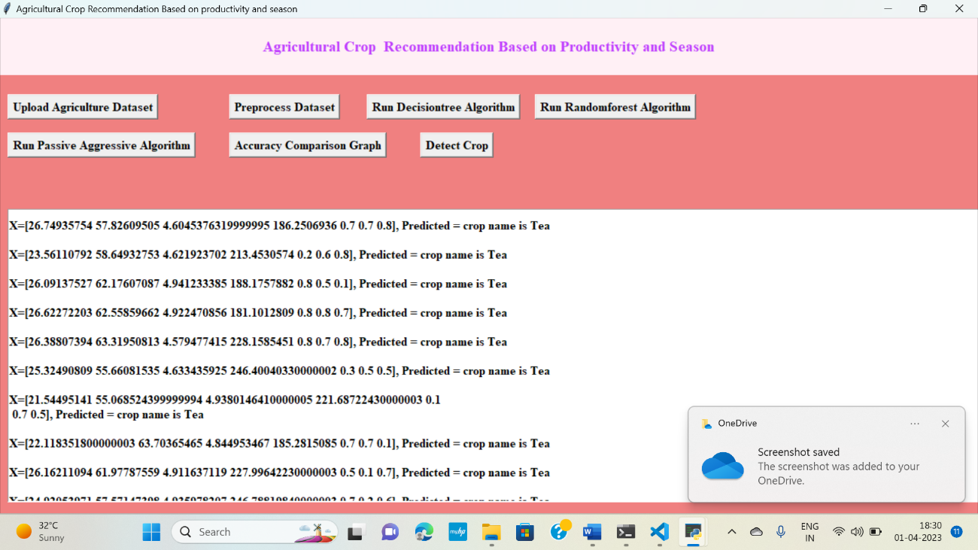

CMRCET B. Tech (CSE) Page No 51

agricultural crop recommendations based on productivity and season

**CHAPTER 6**

**CONCLUSION**

CMRCET B. Tech (CSE) Page No 52

agricultural crop recommendations based on productivity and season

**CHAPTER 6**

**CONCLUSION**

In this project, significance of management of crops was studied vastly. Farmers need assistance with recent technology to grow their crops. Proper prediction of crops can be informed to agriculturists in time basis. Many Machine Learning techniques have been used to analyze the agriculture parameters. Some of the techniques in different aspects of agriculture are studied by a literature study. Blooming Neural networks, Soft computing techniques plays significant part in providing recommendations. Considering the parameter like production and season, more personalized and relevant recommendations can be given to farmers which makes them to yield good volume of production

CMRCET B. Tech (CSE) Page No 53

agricultural crop recommendations based on productivity and season

**CHAPTER 7**

**REFERENCES**

CMRCET B. Tech (CSE) Page No 54

agricultural crop recommendations based on productivity and season

**CHAPTER 7**

## REFERENCES

## [1] Shreya S. Bhanose, Kalyani A. Bogawar (2016) “Crop And Yield Prediction Model”, International Journal of Advance Scientific Research and Engineering Trends, Volume 1,Issue 1, April 2016

## [2] Tripathy, A. K., et al.(2011) "Data mining and wireless sensor network for agriculture pest/disease predictions." Information and Communication Technologies (WICT), 2011 World Congress on. IEEE.

## [3] Ramesh Babu Palepu (2017) ” An Analysis of Agricultural Soils by using Data Mining Techniques”, International Journal of Engineering Science and Computing, Volume 7 Issue No. 10 October.

## [4] Rajeswari and K. Arunesh (2016) “Analysing Soil Data using Data Mining Classification Techniques”, Indian Journal of Science and Technology, Volume 9, May.

## [5] A.Swarupa Rani (2017), “The Impact of Data Analytics in Crop Management based on Weather Conditions”, International Journal of Engineering Technology Science and Research, Volume 4,Issue 5,May.

## [6] M. Ananthara, T. Arunkumar, and R. Hemavathy, Cry: An improved crop yield prediction model using bee hive clustering approach for agricultural data sets,” in Pattern Recognition, Informatics and Medical Engineering (PRIME), 2013 IEEE International Conference , pp. 473- 478

CMRCET B. Tech (CSE) Page No 55

agricultural crop recommendations based on productivity and season

**GITHUB LINK**

https://github.com/SaicharanPadakanti/Agricultural-crop-recommendation

CMRCET B. Tech (CSE) Page No 56